**AI ENABLED INTEGRATED APPLICATION FOR LUGGAGE CAREER SYSTEM**

**A System Requirement Specification**

Submitted in Partial Fulfilment of the Requirements for the Degree of

**Bachelor of Technology in**

**Information Technology**

by

Atish Gorka (2000270110026)

Gaurav Singh (2000270110040)

Kartikey Tyagi (2100270119005)

Sahastranshu Mishra (2000270310134)

Under the Supervision of

Ms. Akansha Shukla



**AJAY KUMAR GARG ENGINEERING COLLEGE, GHAZIABAD**

**DR. A.P.J ABDUL KALAM TECHNICAL UNIVERSITY, LUCKNOW**

October 18, 2023

## DECLARATION

We hereby declare that the work presented in this report entitled “AI ENABLED INTEGRATED APPLICATION FOR LUGGAGE CAREER SYSTEM”, was carried out by us. We have not submitted the matter embodied in this report for the award of any other degree or diploma of any other University or Institute. I have given due credit to the original authors / sources for all the words, ideas, diagrams, graphics, computer programs, experiments, results, that are not my original contribution. I have used quotation marks to identify verbatim sentences and given credit to the original authors / sources.

I affirm that no portion of my work is plagiarized, and the experiments and results reported in the report are not manipulated. In the event of a complaint of plagiarism and the manipulation of the experiments and results, I shall be fully responsible and answerable.

Name : Atish Gorka

Roll No. : 2000270110026

Name : Gaurav Singh

Roll No. : 2000270110040

Name : Kartikey Tyagi

Roll No. : 2100270119005

Name : Sahastranshu Mishra

Roll No. : 2000270310134

## CERTIFICATE

Certified that **Atish Gorka** (2000270110026), **Gaurav Singh** (2000270110040), **Kartikey Tyagi** (2100270119005), **Sahastranshu Mishra** (2000270310134) has carried out the Project / Research entitled **“AI ENABLED INTEGRATED APPLICATION FOR LUGGAGE CAREER SYSTEM”** for the award of **Bachelor Of Technology** from DR.APJ ABDUL KALAM TECHNICAL UNIVERSITY LUCKNOW under my supervision. The project / research embodies results of original work, and studies are carried out by the students himself and the contents of the work do not form the basis for the award of any other degree to the candidate or to anybody else from this or any other University/Institution.

**(Ms. Akansha Shukla)**

(Associate Professor)

(CSE Department, AKGEC Ghaziabad)

Date : 15/10/2023

**ABSTRACT**

The importance of a luggage carrier system in today's era lies in its ability to address the challenges posed by increased travel, globalization, security concerns, and technological advancements. By providing efficient, secure, and data-driven solutions, these systems play a crucial role in shaping the future of the transportation and logistics industry. This project implements, the AI-enabled luggage carrier management system represents a paradigm shift in the transportation industry. By combining real-time tracking, route optimization, resource allocation, security features, GPS services, and advanced analytics, the system not only addresses current challenges but also sets the stage for a more efficient, secure, and data-driven future in luggage management.

The system incorporates a comprehensive set of features, including real-time luggage tracking, route optimization, resource allocation, security enhancements, and user authentication. Leveraging cutting-edge technologies such as GPS services, data analytics, and predictive modeling, the system aims to revolutionize the luggage management landscape. The real-time luggage tracking feature ensures that both carriers and users can monitor the exact location and status of luggage throughout its journey. Route optimization and resource allocation algorithms work in tandem to streamline carrier operations, minimizing travel time and maximizing resource utilization. Security features embedded within the system add an extra layer of protection, safeguarding luggage from potential threats or unauthorized access.

**Contents**

DECLARATION i

CERTIFICATE ii

ABSTRACT iii

Introduction 1

1.1 Problem Statement 1

1.2 Scope of the Project 2

1.3 Objective of the project 4

1.4 Description of the use case domain 4

2. Literature Review 7

3. Proposed Model 11

4. Designing Of The Project 13

4.1 Zero Level DFD 13

4.2 One Level DFD 13

4.3 Use Case Diagram 14

5. Methodology Used 17

5.1 ER Diagram 17

5.2 Class Diagram 18

5.3 Sequence Diagram 19

6. Gantt Chart 20

7.Outcome Of The Project 21

8. References 23

**Chapter 1**

# Introduction

## Problem Statement

The AI-enabled integrated application for a luggage carrier system represents a cutting-edge solution poised to revolutionize the efficiency, security, and overall experience within the logistics and transportation industry. By seamlessly merging artificial intelligence with sophisticated logistics management, this innovative application promises to optimize every facet of the luggage transit process.

From automated route optimization based on real-time data to predictive maintenance leveraging advanced algorithms, the system ensures a streamlined and reliable service. Incorporating technologies such as GPS, and encryption based security, the application not only tracks the real-time location of luggage but also prioritizes security through advanced authentication measures. With features like image recognition for sorting, environmental impact analysis, and comprehensive data analytics for business intelligence, this AI-enabled application represents a holistic approach to modernize and enhance the luggage carrier ecosystem. Identifying the problems that an AI-enabled luggage carrier management system aims to address is crucial for its successful implementation. Here are some common challenges and issues that such a system may seek to solve:

**Inefficiency in Luggage Handling:**

Traditional luggage handling systems may suffer from inefficiencies, leading to delays, lost luggage, or suboptimal use of resources.

**Traffic Congestion:**

High traffic areas, such as airports, may experience congestion and bottlenecks in luggage movement, especially during peak times.

**Lack of Real-Time Visibility:**

Limited visibility into the real-time location and status of luggage can lead to challenges in tracking, potentially causing delays and inconvenience for passengers.

**Resource Allocation Challenges:**

Manual resource allocation, such as the deployment of luggage carts and personnel, can be suboptimal, leading to resource shortages or overallocation.

**Security Concerns:**

Traditional luggage handling systems may face security challenges, including the risk of lost or mishandled luggage, or unauthorized access to luggage storage areas.

**Ineffective Route Planning:**

Without dynamic and intelligent route planning, luggage carriers may follow suboptimal paths, contributing to congestion and inefficiency.

**Customer Frustration:**

Delays, lost luggage, or lack of communication regarding the status of luggage can result in customer frustration and a negative overall experience.

**Manual Tracking and Handling:**

Reliance on manual tracking and handling processes can be error-prone and may not scale well in environments with high volumes of luggage.

**Environmental Impact:**

Inefficient operations can contribute to unnecessary energy consumption and environmental impact, especially in large transportation hubs.

**Lack of Adaptability to Changes:**

Traditional systems may struggle to adapt to changing conditions, such as variations in passenger traffic, infrastructure updates, or changes in operational procedures.

**Integration of Emerging Technologies:**

The integration of new technologies, such as AI, autonomous vehicles, and IoT devices, may present integration challenges with existing systems.

**Communication Gaps:**

Lack of effective communication channels between the luggage management system and passengers may lead to misunderstandings and dissatisfaction.

Identifying these problems serves as a foundation for designing an AI-enabled luggage carrier management system that addresses specific pain points, enhances operational efficiency, and improves the overall customer experience in transportation and logistics settings.

## 1.2 Scope of the Project

The scope of an AI-enabled luggage carrier management system is broad and encompasses various aspects within the domain of transportation and logistics. Here's an overview of the key elements that define the scope of such a system:

**Transportation Hubs:**

Airports: The primary focus is often on airports, where large volumes of luggage need to be efficiently managed due to the constant influx and departure of flights.

Train Stations, Bus Terminals, and Seaports: The system can extend to other transportation hubs, optimizing luggage handling in diverse settings.

**Luggage Tracking and Visibility:**

Real-time tracking of luggage within the transportation hub to provide visibility to both operators and passengers.

**Route Optimization:**

AI-driven algorithms for optimizing the routes of luggage carriers, minimizing congestion, and ensuring timely delivery to designated locations.

**Resource Allocation:**

Efficient allocation of resources such as luggage carts, personnel, and other assets based on real-time demand and historical data.

**Security Enhancement:**

Integration of AI technologies to enhance security through features like facial recognition, anomaly detection, and monitoring for suspicious activities.

**Customer Interaction:**

Providing passengers with real-time information about the location and status of their luggage, as well as interactive interfaces for queries and assistance.

**Integration with Emerging Technologies:**

Incorporating and integrating technologies such as IoT, autonomous vehicles, and robotics for seamless luggage handling.

**Adaptability to Changing Conditions:**

Designing the system to adapt to fluctuations in passenger numbers, changes in infrastructure, and variations in operational procedures.

**Data Analytics and Predictive Modeling:**

Utilizing data analytics and predictive modeling to analyze historical data, forecast demand, and optimize operations for future scenarios.

**Environmental Sustainability:**

Incorporating features that contribute to energy efficiency, reduced environmental impact, and adherence to sustainability goals.

**Scalability**:

Ensuring that the system can scale efficiently to handle varying levels of demand in both small and large transportation hubs.

**Regulatory Compliance:**

Complying with relevant regulations and standards related to luggage handling, security, and data privacy.

**Interoperability:**

Designing the system to be compatible with existing infrastructure and capable of interoperability with other systems within the transportation ecosystem.

**Continuous Improvement:**

Establishing mechanisms for gathering and analyzing feedback from both operators and passengers to drive continuous improvement in the system's performance.

**Cost Efficiency:**

Striving for cost-effective operations by optimizing resource usage, reducing delays, and minimizing the need for manual interventions.

The scope of an AI-enabled luggage carrier management system is dynamic, evolving with advancements in technology and the changing landscape of transportation. It is not limited to a single technology or methodology but involves a holistic approach to enhance the efficiency, security, and overall passenger experience in luggage handling across various transportation hubs.

## Objective of the project

The objective of the system that is aim to transform the luggage carrier system into a technologically advanced, secure, and customer-centric service that sets new standards for efficiency, reliability, and user satisfaction with the below features.

User Authentication

AI Vision based image reading

Encryption based security

AI based distance, travel supports

Real time tracking

User friendly GUI

# Description of the use case domain

The use case domain for the AI-enabled luggage carrier management system spans across various sectors within the transportation and logistics industry. The system is designed to address the complexities and challenges associated with the management of luggage, ensuring efficiency, security, and an enhanced user experience. Below is a detailed description of the key elements within the use case domain:

**Transportation and Logistics Providers:**

The primary users of the system include transportation companies, airlines, shipping companies, and other logistics providers involved in the movement of goods and luggage. These entities deploy the AI-enabled system to optimize their operations and enhance the overall efficiency of luggage transportation.

**Airports and Travel Hubs:**

Airports and major travel hubs play a pivotal role in the use case domain. The luggage carrier system integrates with airport infrastructure to streamline the handling and tracking of luggage from check-in to final destination, ensuring a seamless travel experience for passengers.

**Luggage Carriers and Handlers:**

Luggage carriers, whether automated systems or human handlers, utilize the AI-enabled features for real-time tracking, route optimization, and efficient resource allocation. The system assists carriers in delivering luggage with precision and minimizing delays.

**Travelers and End Users:**

End users, such as travelers and customers, are integral to the use case domain. The system provides a user-friendly interface for travelers to track the location of their luggage in real time, enhancing their overall experience and providing peace of mind during their journey.

**E-commerce and Retail Logistics:**

With the rise of e-commerce, the system extends its utility to the management of goods purchased online. Retailers and e-commerce platforms integrate the luggage carrier system to ensure efficient and secure delivery of purchased items to customers.

**Security and Compliance Entities:**

Security agencies and regulatory bodies are part of the use case domain, as the system incorporates security features to prevent theft, unauthorized access, and other security breaches. The system also ensures compliance with regulations governing the transportation of goods.

**Data Analysts and Planners:**

Professionals involved in data analysis and logistics planning benefit from the data analytics and predictive modeling capabilities of the system. These features provide valuable insights into usage patterns, help identify operational bottlenecks, and enable proactive planning for future demands.

**Technology Providers:**

Companies that develop and provide technologies such as GPS services, RFID, and AI algorithms are part of the use case domain. These technologies are integrated into the luggage carrier system to enhance tracking accuracy, security, and overall functionality.

**Maintenance and Support Teams:**

Maintenance and support teams are involved in the use case domain to ensure the continuous operation and reliability of the system. They handle issues related to hardware, software, and overall system performance.

**Global and Local Transportation Networks:**

The system is designed to operate within both global and local transportation networks. Whether it's international airports, regional transit hubs, or local courier services, the use case domain encompasses a wide range of transportation networks.

In summary, the use case domain of the AI-enabled luggage carrier management system is expansive, involving multiple stakeholders within the transportation and logistics ecosystem. The system's features cater to the diverse needs of carriers, travelers, logistics providers, and other entities involved in the efficient and secure transportation of luggage and goods.

# Chapter 2

# Literature Review

Utilizing machine learning on freight transportation and logistics applications: A review by Kalliopi et. al 2023 [1] : This review article explores and locates the current state-of-the-art related to application areas from freight transportation, supply chain and logistics that focuses on arrival time, demand forecasting, industrial processes optimization, traffic flow and location prediction, the vehicle routing problem and anomaly detection on transportation data. This review categorizes the related works according to machine learning methodologies so as to present the methods’ evolution through time, their combinations and their connection with the various applications in the specified fields. Thus, a reader would effortlessly get insights about the current state-of-the-art related to machine learning in freight transportation and related application areas.

Smart Luggage Carrier System by Terance et. al 2022 [2] : The main idea of this project, Smart Luggage Carrier System (SLCS) Using IoT, is to develop a user-friendly luggage carrier. The act of dragging luggage all over the place has been a practice since the olden age. The motivation behind the project has been the concept of a luggage system that conveys its weight, tracks its location, and follows a designated path. This motivation has guided the project to be user-friendly and operable. In this project, an effort was made to address the problem of 'Back-Ache, Spinal Cord Bends, Muscle Strain, etc.' that arises due to the burden of carrying heavy luggage on the back. An IR sensor, connected to an Arduino Nano interfaced with an L293d motor driver, is utilized for the movement of the luggage carrier along different predefined paths through the assistance of DC motors. Obstacle detection is facilitated by an ultrasonic sensor; if any obstacle is present in front of the luggage, an alert will be sounded through the buzzer. The location of the luggage carrier is tracked using GPS and GPRS modules. In the event of a loss of the luggage carrier, a message can be received on a smartphone through the GPS module

Ultraviolet sterilization information provision system of baggage carts and arriving baggage for airports by Tetsuya et. al 2022 [3]: In this study, a system has been developed to enhance border quarantine measures at airports, focusing on the sterilization of both baggage carts and arriving passenger baggage, hereafter referred to as arrival baggage. The system integrates ultraviolet (UV) sterilization and information communication technology to ensure a thorough sterilization process and efficient information dissemination. Through UV irradiation, the system sterilizes both arrival baggage and baggage carts, prioritizing passenger safety, as well as the well-being of airport, airline, and customs staff who may have direct contact with the sterilized items. The system employs radio frequency identification technology to allow passengers easy access to sterilization information. This information, readily available to passengers, enhances the overall safety and security measures within the airport environment. Furthermore, the system offers passengers the convenience of tracking their baggage in real-time, providing details such as the current location and estimated delivery time. This not only improves passenger experience but also facilitates social distancing at baggage claim areas, serving as an effective infection prevention measure. To validate the practicality and effectiveness of the developed system, a proof of concept demonstration was conducted at Central Japan International Airport. The demonstration aimed to verify the feasibility of the system and identify any potential challenges that need to be addressed for its successful

Smart Luggage Carrier system with Theft Prevention and Real Time TrackingUsing Nano Arduino structure by Krishnan et. al 2020 [4] : This paper presents a Smart Luggage Carrier System with integrated theft prevention and real-time tracking capabilities, utilizing a Nano Arduino structure. The system addresses the growing need for advanced solutions in luggage management. By employing Nano Arduino technology, the system aims to enhance the security and tracking functionalities of luggage carriers. The proposed system incorporates theft prevention measures, ensuring the safety of luggage during transit. Additionally, real-time tracking features provide users with up-to-date information on the location of their belongings.

Smart Luggage System by Afrin Khan et. al 2019 [5]: This work explores the realm of smart luggage systems, aiming to address common challenges encountered by travelers during the carriage of their belongings. By delving into the advancements of technology in luggage design, the paper discusses innovations that contribute to the ongoing improvement of the travel experience. The focus is on leveraging smart technologies to overcome the difficulties associated with conventional luggage, presenting a forward-looking perspective on the intersection of travel and technology.

Luggage tracking system using IOT by Sudha et. al 2019 [6] : The luggage tracking system is designed to track the luggage and bags which gets lost or theft from public and other areas. As people travel, there is always a risk of theft of the luggage and bags which is where the proposed system comes into account. The luggage tracking system works on an alarm basis where an alarm is set up with the arduino uno board and a GPS module. Also the alarm is turned on as soon as the bag is theft and goes outside a particular range. Furthermore, a map is created through which we can track the location of the bag as it moves, as the markers are dropped which in a way gives us the location of the bag as it moves away from the owner. In this, the IoT components are being used like Arduino Board and a GPS Module in order to track the bag and a frontend or mobile application is created in order to monitor.

Improving Baggage Tracking, Security and Customer Services with RFID in the Airline Industry by Deepty et. al [2010] : This work discussed that the Radio Frequency Identification (RFID) stands out as a significant technological advancement in the 21st century, earning recognition among the top ten contributory technologies. The market for RFID technology is rapidly expanding, with enterprises across various industries adopting RFID to enhance operational efficiency and gain a competitive edge. This paper explores the widespread adoption of RFID technology in the aviation industry, particularly within major airports and airlines. The focus is on the application of RFID in baggage handling, a domain where the technology has showcased superior accuracy and performance compared to traditional bar codes. The paper delves into the planning, architecture, and implementation of RFID technology at a major airline, emphasizing its impact on services related to baggage handling, airport/airline security, and frequent flier programs. The integration of RFID technology with networking and database technologies is highlighted as a key enabler for achieving enhanced services. The findings and insights from this study contribute to a better understanding of the role of RFID in transforming operational processes and improving overall services within the aviation industry.

The state of RFID for effective baggage tracking in the airline industry by Devries 2008[8] : This article examines the state of Radio Frequency Identification (RFID) as a solution to the problem of tracking baggage within the commercial aviation industry. The benefits and drawbacks of RFID are examined. The cost of RFID tags is still a major barrier to implementation for leaders within the industry. The technology will definitely benefit those with successful implementations as it will lead to improved customer service and satisfaction. The challenge is in building the business case, which involves cooperation between airports and airlines in providing RFID infrastructure. Benefits must be analysed over cross-functional processes owned by different departments and organisations.

**Chapter 3**

# Proposed Model

In the rapidly evolving landscape of luggage management, our proposed AI-enabled luggage carrier system stands out as a transformative solution, surpassing conventional systems through a comprehensive set of features designed to revolutionize the industry. Embracing cutting-edge artificial intelligence (AI) technologies, our system introduces a paradigm shift in the way luggage is handled, offering a superior level of efficiency, security, and user experience. Unlike traditional systems, our AI-enabled solution boasts real-time luggage tracking capabilities, allowing both carriers and users to monitor the precise location and status of luggage throughout its entire journey. This feature enhances transparency, minimizes the risk of loss, and ensures an unparalleled level of customer satisfaction. The figure 3.1 describes about the architectures of the proposed system.

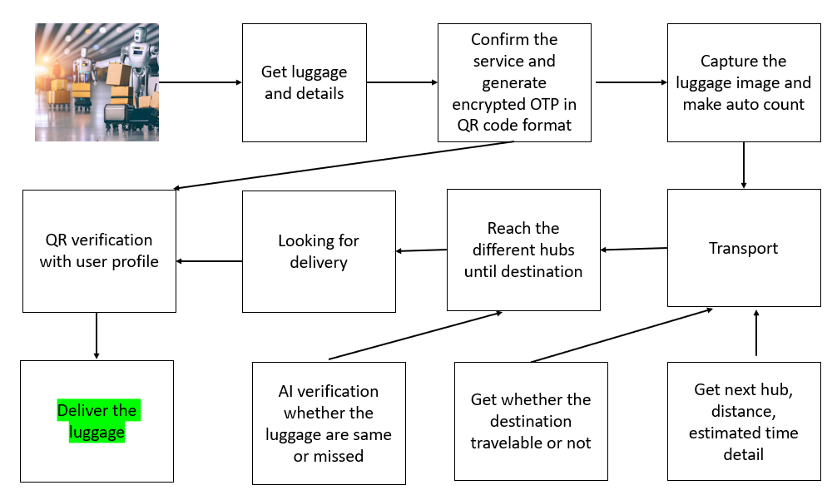

Figure 3.1 : Architechture Diagram

The system's route optimization and resource allocation algorithms represent a departure from outdated methods. By leveraging AI, we empower carriers to streamline operations, minimizing travel time and maximizing resource efficiency. This not only enhances overall system productivity but also contributes to cost savings—an advantage that sets our proposed model apart from its predecessors.

Security is a paramount concern, and our system addresses it comprehensively. Through robust security features, unauthorized access, theft, and potential breaches are mitigated, ensuring the safety of luggage and instilling confidence in both carriers and passengers. This is a significant advancement compared to traditional systems that may lack such robust protective measures.The integration of real-time tracking, GPS services, and data analytics sets our system apart in terms of responsiveness and adaptability. Users can access up-to-the-minute information about their luggage, and carriers benefit from data analytics and predictive modeling to proactively address challenges and optimize operations. This forward-looking approach ensures that our system is not only responsive to current needs but also anticipates future demands.

User authentication and authorization mechanisms provide an additional layer of security and personalization. Unlike previous systems that may lack stringent user controls, our proposed model ensures that sensitive information is accessed only by authorized individuals, safeguarding against potential breaches and misuse.

In essence, our AI-enabled luggage carrier management system represents a leap forward in the industry, offering a holistic solution that transcends the limitations of traditional models. The integration of real-time tracking, route optimization, resource allocation, security features, GPS services, and advanced analytics positions our system as a comprehensive and forward-thinking answer to the evolving needs of modern luggage management.

**Chapter 4**

# Designing Of The Project

**DATA FLOW DIAGRAM**

DFD is the abbreviation for Data Flow Diagram. The flow of data of a system or a process is represented by DFD. It also gives insight into the inputs and outputs of each entity and the process itself. DFD does not have control flow and no loops or decision rules are present. Specific operations depending on the type of data can be explained by a flowchart. Data Flow Diagram can be represented in several ways. The DFD belongs to structured-analysis modeling tools. Data Flow diagrams

are very popular because they help us to visualize the major steps and data involved in software-system processes.

# 4.1 Zero Level DFD

It is also known as a context diagram. It’s designed to be an abstraction view, showing the system as a single process with its relationship to external entities. It represents the entire system as a single bubble with input and output data indicated by incoming/outgoing arrows.

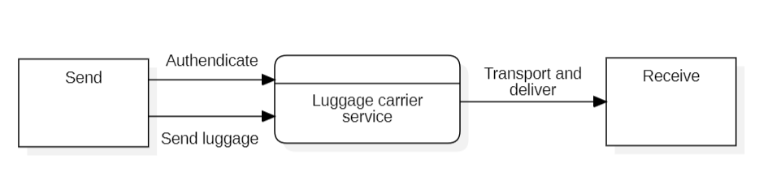

Figure 4.1 : Level 0 DFD

# 4.2 One Level DFD

In 1-level DFD, the context diagram is decomposed into multiple bubbles/processes. In this level, we highlight the main functions of the system and breakdown the high-level process of 0-level DFD into sub processes.

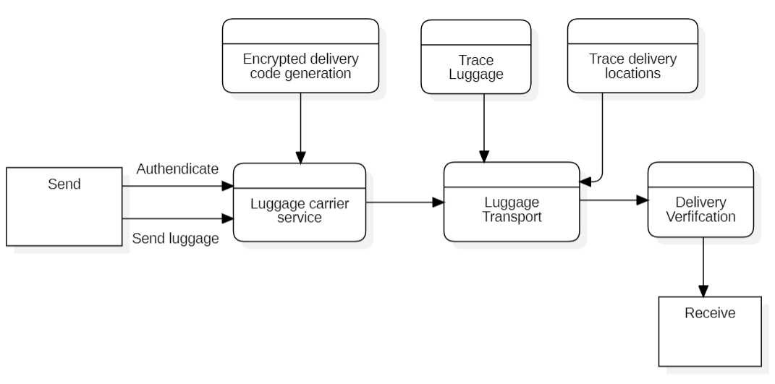

Figure 4.2 : Level 1 DFD

# 4.3 Use Case Diagram

To model functionality of the system, we use different actors, external entities (“roles”), and the associated use cases represented on the use case diagram. The use case diagrams are also used to show the functions, actions and services that the systems will perform

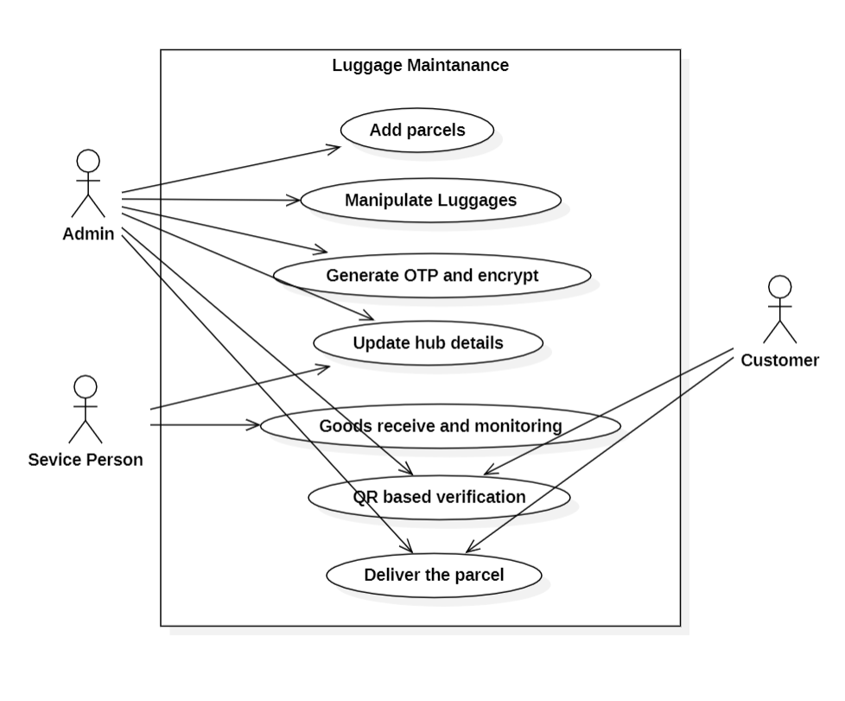

Figure 4.3 : Use case 1

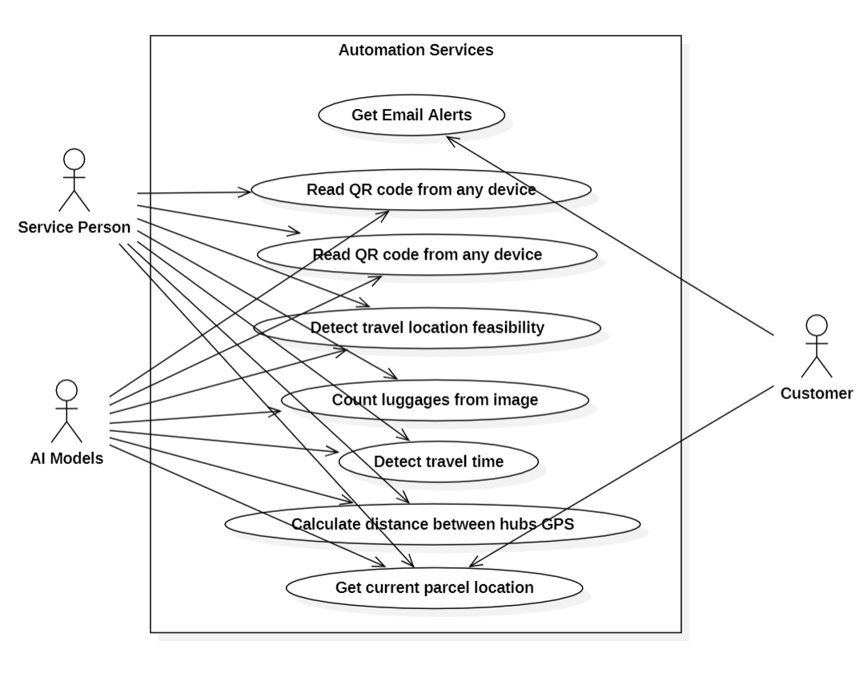

Figure 4.4 : Use case 2

**Chapter 5**

# Methodology Used

The methodology used in this project can be represented by following diagrams :

# 5.1 ER Diagram

An Entity-Relationship (ER) diagram is a visual representation used in software engineering and database design to model the entities (things) and their relationships in a system. In the context of a AI enabled luggage carrier system project, an ER diagram for the System Requirement Specification (SRS) document might include entities related to various aspects of the project. This ER diagram provides a high-level overview of the entities and their relationships within the Smart luggage carrier System. It helps in understanding how data is structured and how different components of the system interact with one another. This forms a crucial foundation for the development of the system and ensures that all relevant information is captured and organized effectively as part of the SRS document.

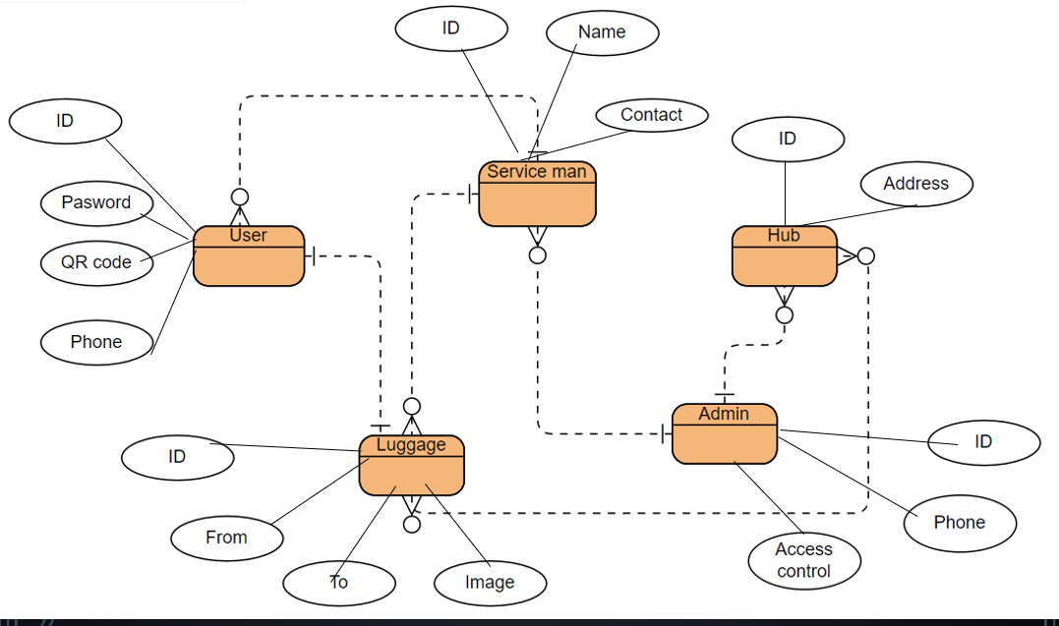

Figure 5.1: ER Diagram

# 5.2 Class Diagram

Class diagrams are structural Unified Modeling Language (UML) diagrams that are used to demonstrate the static view of the system. They are used to document, visualize and describe different aspects of the object-oriented system as well as for constructing the executable functions and developing the programming code for the system. Class diagrams are widely used for describing the attributes and operations of the class and constraints imposed on the system. In a crowdfunding system with blockchain, you’ll typically have classes representing users, projects, contributions, transactions, and the blockchain itself.

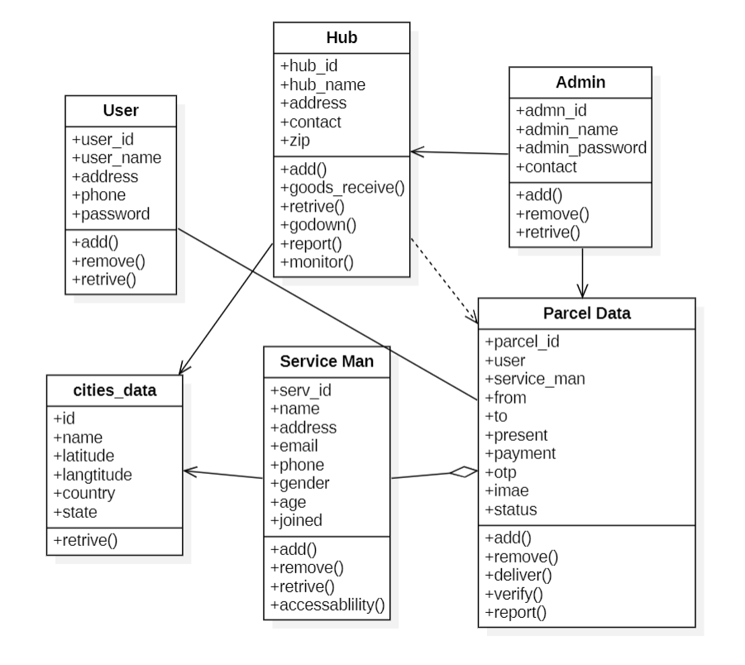

Figure 5.2: Class Diagram

# 5.3 Sequence Diagram

A sequence diagram is a visual representation of the interactions and messages exchanged between different components or objects in a system, typically illustrating the flow of a particular use case or scenario.

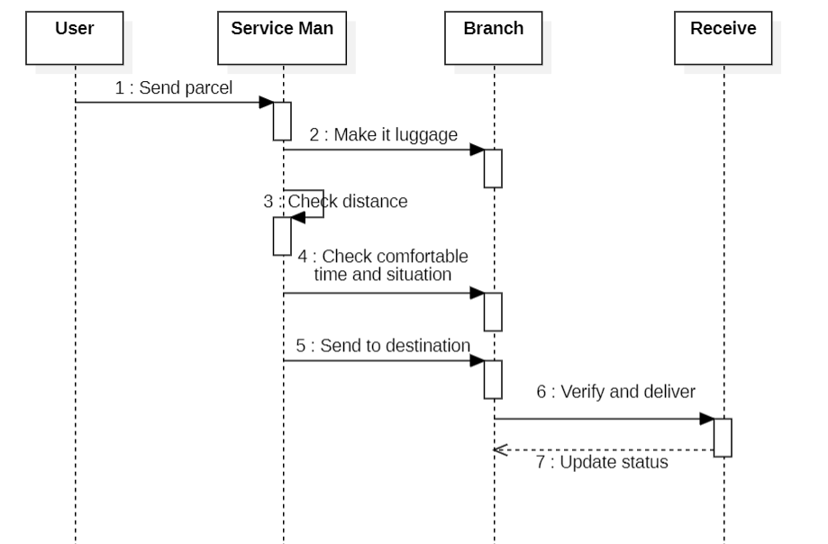

Figure 5.3: Sequence Diagram

A Data Flow Diagram (DFD) is a graphical representation of the flow of data within a system. It is a visual tool that illustrates how data moves between processes, data stores, and external entities. Below is a simplified representation of a Data Flow Diagram for a AI enabled luggage career system.

**Chapter 6**

# Gantt Chart

The Gantt chart for the AI enabled luggage career system project, outlines the structured timeline from initiation to conclusion.

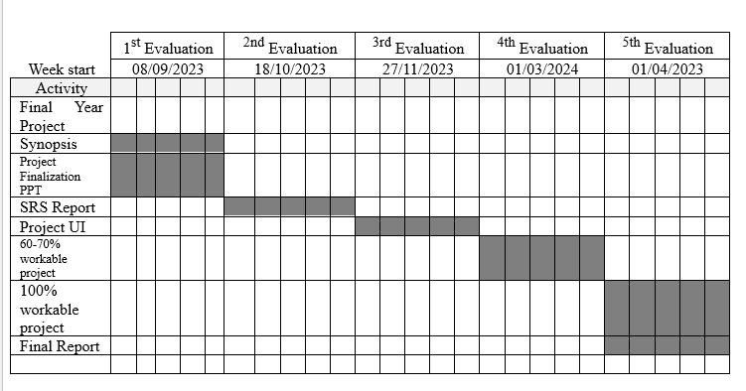

Figure 6.1: Gannt Chart Diagram

**Chapter 7**

# Outcome Of The Project

The outcome of the proposed AI-enabled luggage carrier management system project is expected to yield several significant benefits and improvements in the realm of luggage transportation and management. The specific outcomes include:

* Enhanced Efficiency: The implementation of real-time luggage tracking, route optimization, and resource allocation features is anticipated to result in a substantial enhancement of operational efficiency for carriers. This could lead to reduced travel times, improved route planning, and optimized resource utilization.
* Improved Security Measures: The incorporation of robust security features is expected to significantly enhance the safety and security of luggage during transportation. Unauthorized access, theft, and potential security breaches are mitigated, providing a more secure environment for both carriers and passengers.
* User Satisfaction: Real-time tracking capabilities and user-friendly interfaces contribute to an improved user experience. Passengers can have greater confidence in the safety and location of their luggage, leading to increased satisfaction with the overall luggage management process.
* Cost Savings: Through route optimization and resource allocation algorithms, the project aims to contribute to cost savings for carriers. This could result from minimized travel times, optimized routes, and efficient use of resources, providing a competitive advantage in the market.
* Proactive Problem Resolution: The integration of data analytics and predictive modeling allows carriers to proactively identify and address operational challenges. This forward-looking approach enables carriers to anticipate potential issues and optimize their operations accordingly.
* Adaptability to Industry Trends: The proposed system is designed to be adaptable to emerging trends in the transportation and logistics industry, such as the growth of e-commerce and changing consumer demands. This adaptability ensures that the system remains relevant and effective in a dynamic market.
* Enhanced Data Insights: Data analytics and predictive modeling features provide carriers with valuable insights into usage patterns, potential bottlenecks, and future demands. This information empowers carriers to make informed decisions and continuously improve their operations.
* Improved Authentication and Authorization: The user authentication and authorization mechanisms contribute to improved security by ensuring that only authorized individuals have access to sensitive information. This

In summary, the project aims to deliver a comprehensive luggage management system that not only addresses current challenges but also anticipates and adapts to future industry trends. The anticipated outcomes include improvements in efficiency, security, user satisfaction, and cost-effectiveness, positioning the proposed system as a valuable and forward-thinking solution in the transportation and logistics sector.

# Chapter 8

# References

[1] Kalliopi Tsolaki, Thanasis Vafeiadis, Alexandros Nizamis, Dimosthenis Ioannidis and Dimitrios Tzovaras, Utilizing machine learning on freight transportation and logistics applications: A review, ICT Express 9, Elsevier, Volume 9, Issue 3, June 2023, https://doi.org/10.1016/j.icte.2022.02.001

[2] Terence, E. and Reddy, Siva and Reddy, K. Madhu and Reddy, T. Veera, Smart Luggage Carrier System, Proceedings of the International Conference on Innovative Computing & Communication (ICICC), May 27, 2022. Available at SSRN: https://ssrn.com/abstract=4121060 or http://dx.doi.org/10.2139/ssrn.4121060

[3] Tetsuya Manabe, Kazuo Mizuno, Keisuke Hatano and Masahiko Kaneko, "Ultraviolet sterilization information provision system of baggage carts and arriving baggage for airports", IATSS Research, December 2022. DOI:10.1016/j.iatssr.2022.12.004

[4] P. L. S. Krishnan, R. Valli, R. Priya and V. Pravinkumar, Smart Luggage Carrier system with Theft Prevention and Real Time TrackingUsing Nano Arduino structure, 2020 International Conference on System, Computation, Automation and Networking (ICSCAN), Pondicherry, India, 2020, pp. 1-5, doi: 10.1109/ICSCAN49426.2020.9262445.

[5] Afrin Khan, Bandini Nalwade, Neha Kharshinge3, Sonali Kamble, SMART LUGGAGE SYSTEM, International Research Journal of Engineering and Technology (IRJET), Volume: 06 Issue: 11, Nov 2019, https://www.irjet.net/archives/V6/i11/IRJET-V6I1130.pdf.

[6] Senthil, Sudha & Krishnamurthy, Brindha & R, Charanya. LUGGAGE TRACKING SYSTEM USING IOT. International Journal of Pure and Applied Mathematics. 117. 49-54. September2017.

[7] Deepti Mishra and Alok Mishra, "Improving Baggage Tracking, Security and Customer Services with RFID in the Airline Industry", Improving Baggage Tracking, Security and Customer Services with RFID in the Airline Industry, Vol. 7, No. 2, 2010.

[8] DeVries, Peter. The state of RFID for effective baggage tracking in the airline industry. IJMC. Volume6. 151-164. January 2008. 10.1504/IJMC.2008.016574.